Linear motion: revision
- Explain what is meant by a scalar quantity and give some examples.
- Explain what is meant by a vector quantity and give some examples.
- How long does it take to hear a thunderclap 6.8 km away if the sound wave moves at 340 m/s?
- It takes a pulse of light 35 microseconds to travel down a 5.0 km length of fibre optic cable. How fast does the light move through the cable?
- What is the difference between distance and displacement? When is the magnitude of the displacement equal to the distance travelled?
- A car drives 22 miles north then drives 14 miles south. What is its displacement?
- A raven flies south for 120 seconds at a speed of 12 m/s, then flies 0.56 km north in 80 seconds.
- What is the total distance?
- What is the total displacement?
- What is the average speed?
- What is the average velocity?

- What is the acceleration of an object that steadily increases its speed from 6.0 m/s to 18.0 m/s over a 2.0 second time interval without changing direction?
- What is the acceleration of an object that maintains a steady speed of 24.0 m/s for 6.0 seconds without changing direction?
- A car that is initially moving at 22 m/s hits the brakes and stops in 5.0 seconds. What is the acceleration?
- An airplane that is initially moving at 320 m/s accelerates at 3.0 m/s2 for 20.0 seconds. How far does it move during that time period and what is its final velocity?
- How long does it take a rock to reach a speed of 24.5 m/s if you drop it from a very tall cliff?
- A baseball is thrown straight upward at a speed of 17 m/s.

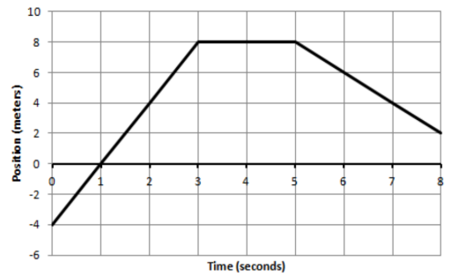
- The graph below shows the position of an object that is moving along a straight line that runs north-south with north being the positive direction.
- How far does the object move during the first 3 seconds?
- How fast is the object moving at t=1.0 second? 4
- What is the velocity at t=1, 4, and 7 seconds?
- What is the acceleration at t=7 seconds?
- What is the total displacement?
- What is the average velocity?
- Sketch a velocity time graph that shows the same motion.

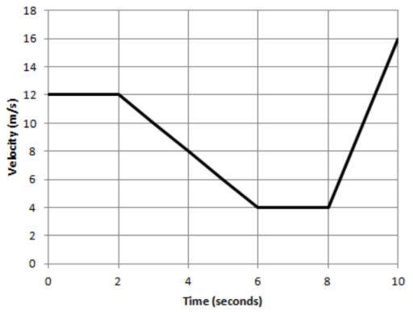
- The graph below shows the velocity of an object that is moving along a straight line that runs east-west with east being the positive direction.
- How far does the object move during the first 2 seconds?
- How fast is the object moving at t=4 seconds?
- What is the acceleration at t=1, 4 and 9 seconds?
- Which direction is the object moving from 2 to 4 seconds?
- What is the total displacement of the object during the entire 10 seconds?

